**1btn teardown and hardware hacking**

1btn is not just open source product but it is an open hardware design too. This means, proud owners of 1btn do have access to firmware, hardware design files as well as actual hardware.

While you already have an overview of technical specifications for 1btn, today I will show you what exactly has been packed inside the 1btn casing. A detailed tear down with explanation will tell you more than what meets an eye about 1btn.

If you have unsealed 1btn, then it is easy to pry open the casings with the help of finger-nail or a blade or a flat-head screw driver. However, if you’ve got a sealed version, be extremely careful while doing this as there are higher chances of damaging top and bottom casings while prying them open.

**A high level view**

1btn is comprised of 4 main parts: top casing, bottom casing, PCB assembly and a LiPo battery.

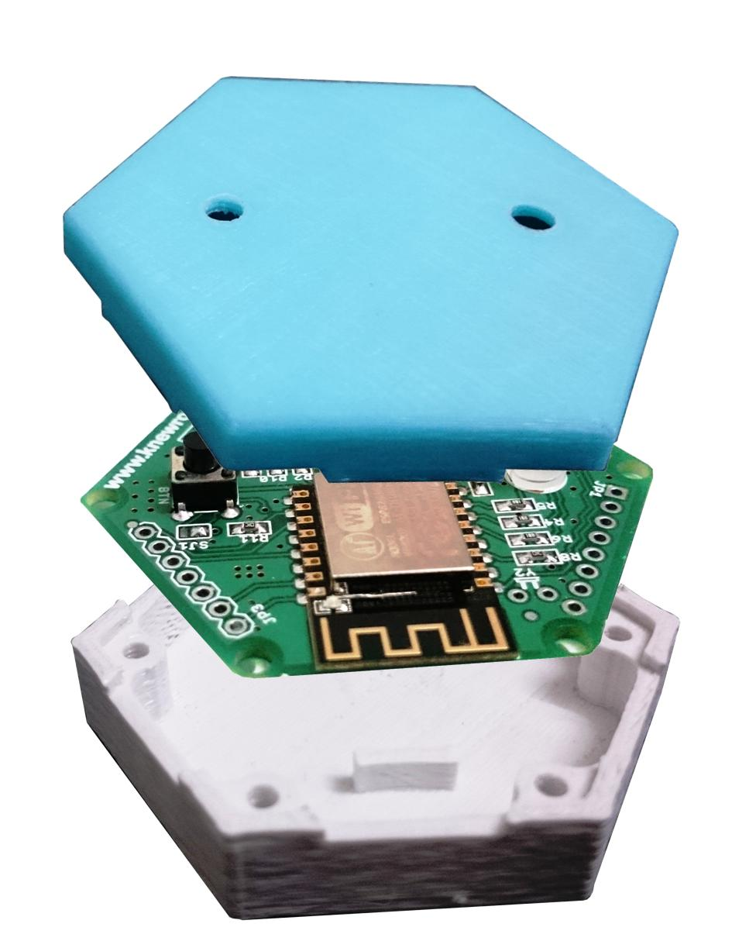

Exploded view in **figure 1** shows these 4 parts. Did you notice two small ribs in the middle of bottom casing? They are meant for fitting the battery snugly between them. Unfortunately, LiPo batteries do not come in uniform size despite being same capacity and therefore there are two designs of bottom casing. One is with these ribs and one is without – to accommodate slightly wider batteries.

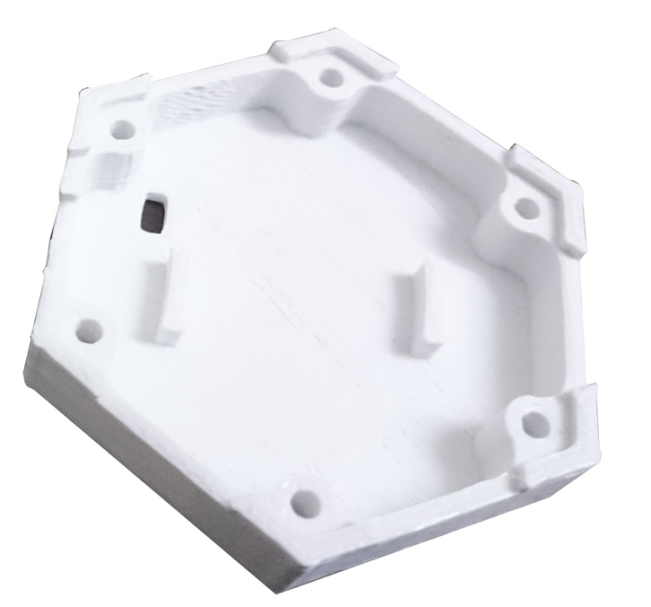

1btn PCB assembly rests on six mounting holes molded into bottom casing which maintain enough distance between the battery and PCB assembly. Interestingly, if you don’t want to seal your 1btn permanently but want to make the fitting firm, you could use 3mm screws (insert from bottom side of casing) to tightly join both the casings and PCBA sandwiched in between, see **figure 2**. Isn’t that a neat arrangement?

**More about PCB assembly**

1btn PCB is a double sided board with components placed on both sides, majorly on top side though. You will see that in **figure 3** there is 3.3V regulator IC placed just under ESP module, which is not seen in some of the other shots of 1btn. That is because the board has been designed to accommodate two different voltage regulators in order to make design manufacturing and inventory friendly. This gives the manufacturing flexibility to use whichever part is available and populate the board accordingly.

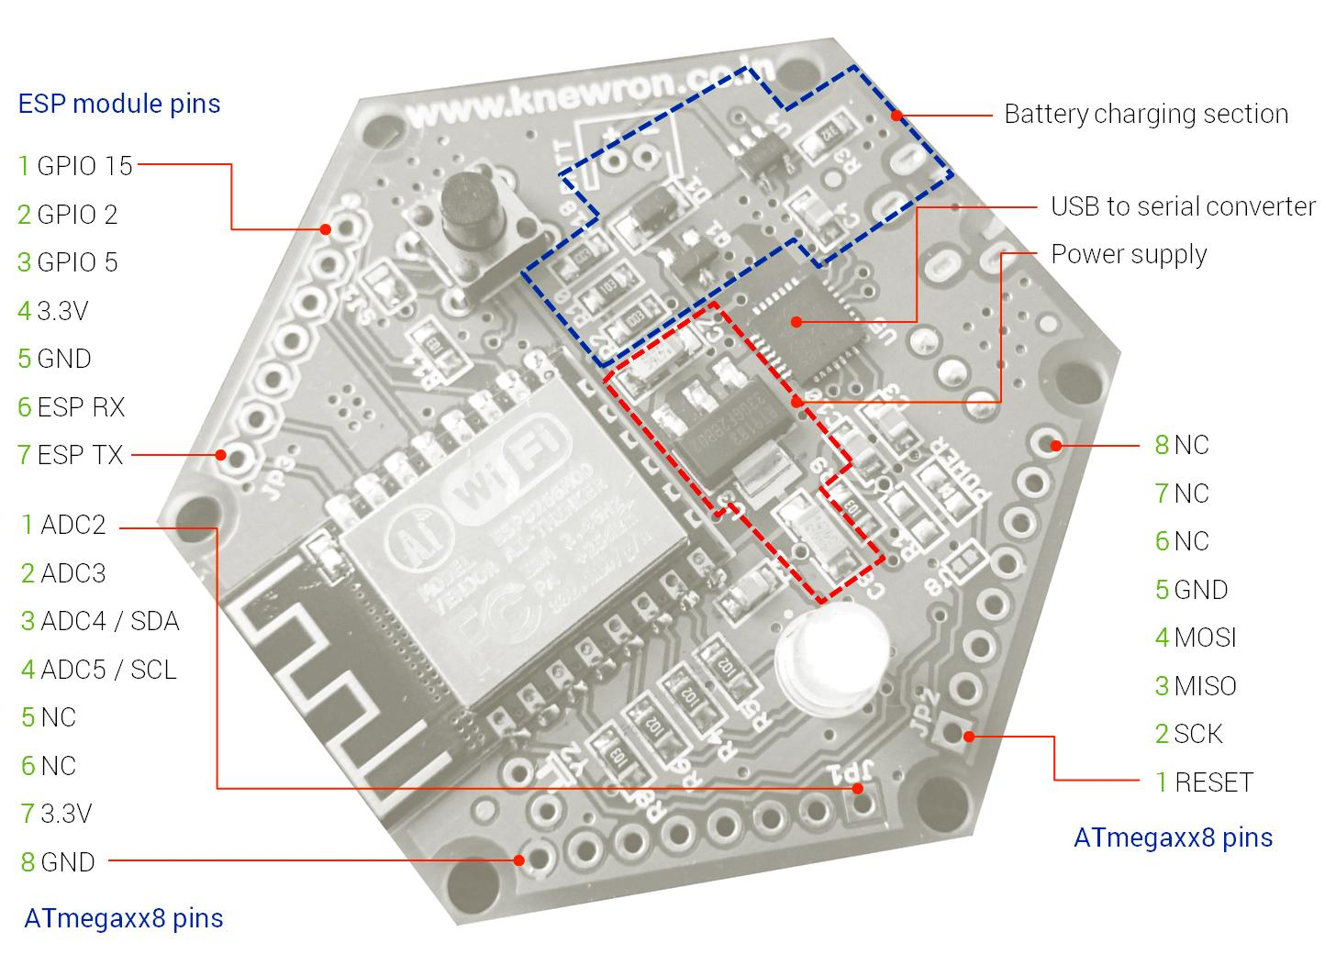

You would also see that there are three expansion ports, JP1, JP2 and JP3 on the board which essentially extend a few more pins of ESP, ISP pins of ATmegaxx8 controller (yes, there is place for one) and analog pins of the same. That means, with enough space inside the casing of 1btn and a few extra I/O taken out, you can add more sensors and enhance 1btn functionality.

**Figure 4** shows bottom side of the PCBA where you will see 4 major sections, one being USB port, second being on-off switch of 1btn, third is jumpers’ section and fourth is footprint for ATmegaxx8P part. You can use any variant from ATmega328P, ATmega88/V or ATmega168/V and alike.

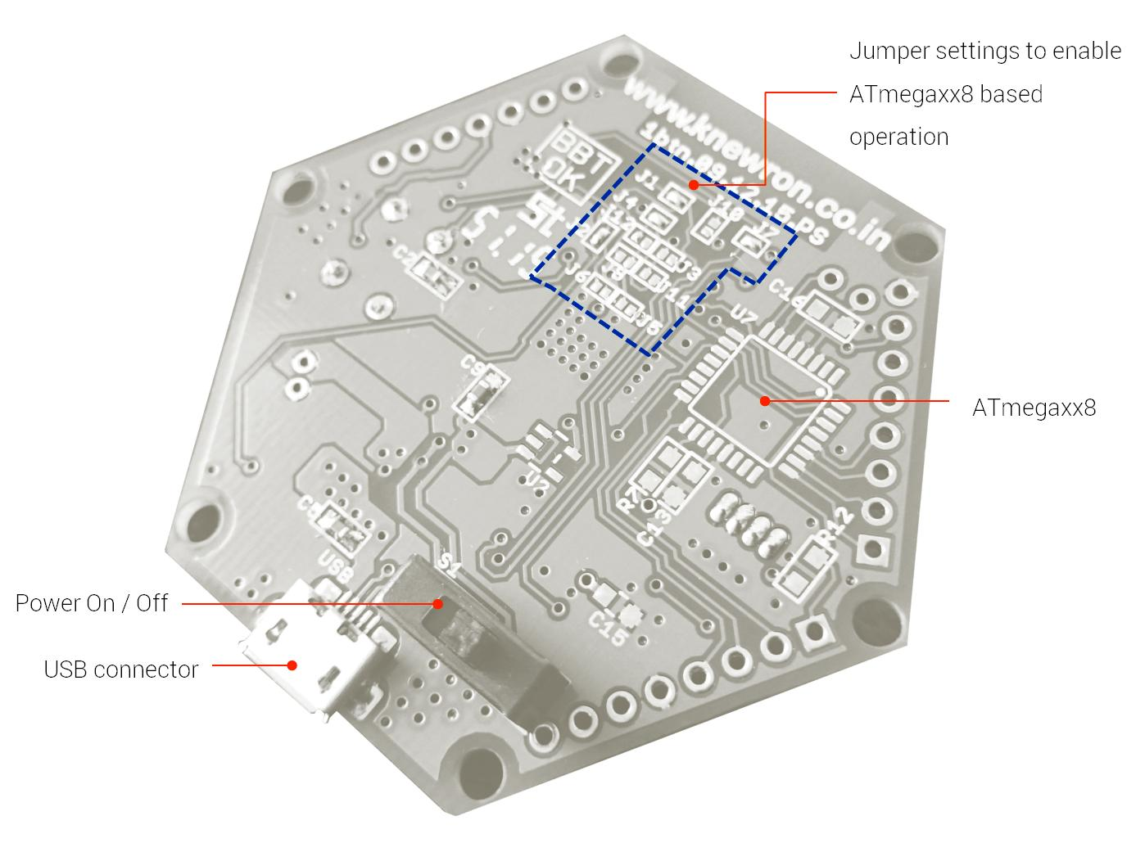

In order to enable ATmega based operation, a few jumper settings need to be changed (more on that would be available in BOM on github) and then you will have power of ATmega along with ESP power, a great combination! A button press then can be diverted from ESP to interrupt pin of ATmega and with RTC crystal placed on board (it’s there too) you can have super low power IoT device which sleep walks most of the time.

Why you would do that, one may ask. With addition of ATmega here, you could basically convert 1btn into multi-press device for starters. Plus you can do a lot with addition of sensors, and wifi together – say your next IoT project in nice little hexagonal casing?

Basically, if you hack 1btn this way, it can change 1btn functionality completely into something else, novel, nifty and interesting.

**About the battery charger of 1btn**

One of the interesting things 1btn’s battery charging circuit is that you don’t have to turn the button ON to charge the battery. The on-off switch is placed after the battery charger and before regulator circuit which enables you to put it to charge while switch may be still in OFF position.

**1btn is open source hardware**

All the components are chosen in such a way that they are easily available at lower MOQ or single piece quantities, everywhere. Most of the passives are in 0805 / 0603 packages which are easy to hand-solder. And there is absolutely nothing complicated on the board which would discourage a maker / hacker from playing around.

Designing for manufacturing as well inventory and part substitutions is very important when working on an open source design. It is to make sure that if part A is not available then part B (or part C) can be used instead without hampering functional or safety aspects.

I strongly believe that while making open source hardware, it is important to keep makers in perspective and design the product accordingly. Using unnecessary sophisticated parts and miniature components works against the spirit of play that encourages community to improvise, enhance, and experiment.

All the design files of 1btn are currently being developed and would be made available on github very soon.

**In the end…**

A few weeks ago [geek.com had this to say about 1btn](http://www.geek.com/news/1btn-is-a-powerful-open-source-do-it-all-button-for-the-internet-1651036/) – “1btn is a powerful, open source, do-it-all button for the Internet; it can already do a lot, and once there’s a community hacking away at it, the possibilities are virtually limitless.”

Happy hacking with 1btn!